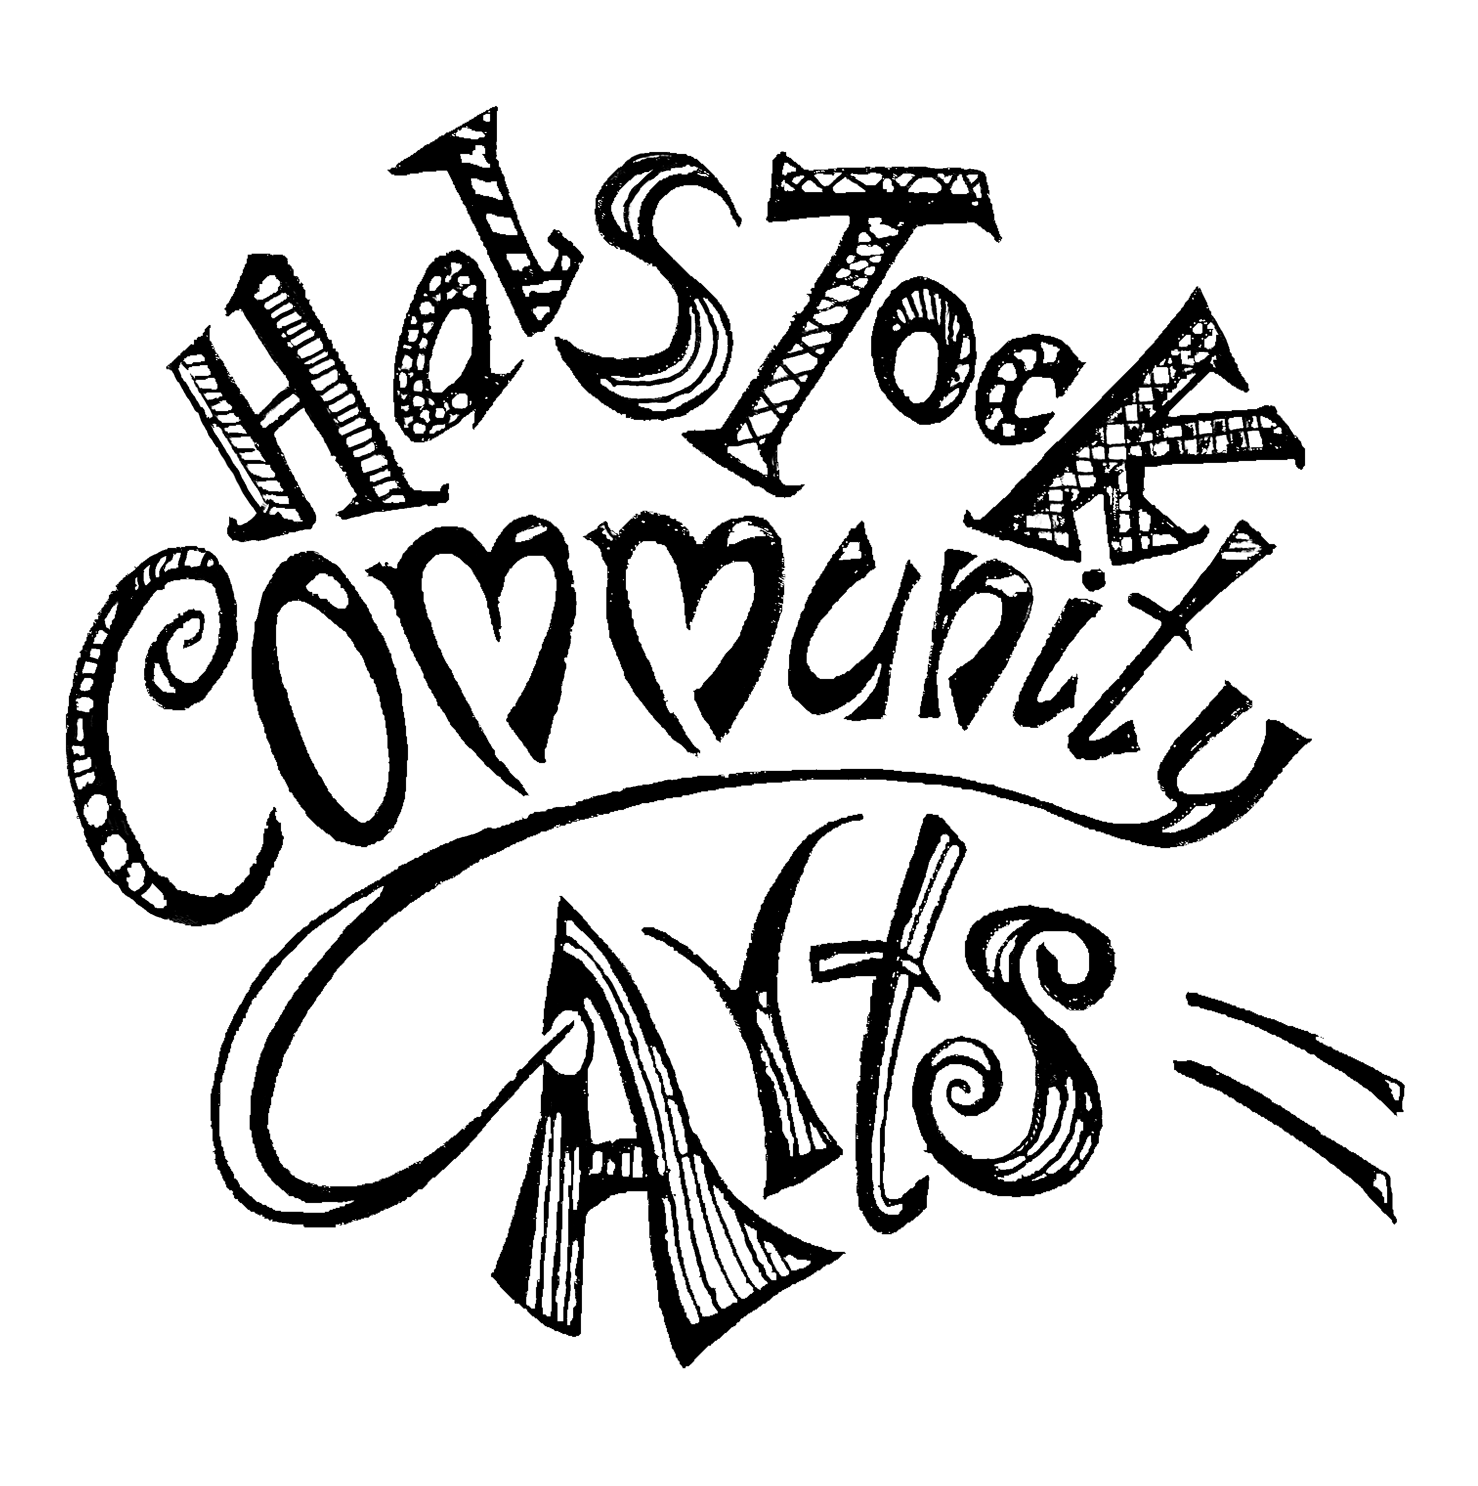

Halstock Community Arts Award Application 2025

Applications will be accepted in written or voice note format. Please email to: halstockcommunityartsawards@gmail.com

Full Name:

Address:

Email Address:

Contact number:

Date of birth if under 25:

Brief summary of your artistic experience to date:
Maximum 300 words

Details of the project that you intend to use the Bursary funding for:
Maximum 300 words

Names and contact details of two referees:
(N.B These should be individuals who are familiar with your artistic work and may not be family members)

Name:
Email address:
Phone contact:

Name:
Email address:
Phone contact:

Signature………………………………………………………………………………………………….

Halstock Community Arts (HCA) Arts Awards 2025
(halstockcommunityartsawards@gmail.com)

Terms and Conditions

1. The Arts Awards Scheme:
The HCA Committee will be awarding up to two £500 Arts Awards to selected candidates in 2025.

2. Eligibility:
Applicants must live or work within a 20 mile radius of Halstock, Dorset. Priority for one of the awards will be given to applicants under the age of 25.

3. Selection Process:
The decision as to who will receive the Arts Awards funding will be made by the HCA Committee and their decision will be final

4. Publicity:
Arts Award recipients are deemed to agree by virtue of their application to the publication of their name and artistic details as well as to the use of their photograph for the purposes of publicity via local and social media outlets.
Successful applicants will be required to provide photographs and a short description/review of the selected project once completed.

5. References:
Applicants must provide the names of two independent referees who are familiar with their artistic work. Family members of the applicants are excluded from providing a reference.

6. Payment of the awards:
Successful applicants will be required to provide the name and account details of their bank account into which payments will be made. The account must be with a recognised bank in the UK.

Closing date for applications 1st March 2026

20 mile radius from Halstock Village Hall – could you be eligible?

